WhatsCook

Revisions
Version | Primary Author(s) | Description of Version | Date Completed
1.0 | Sushant Kumar | Initial Draft | 06/20/2015

Contents
Revisions 2
Contents 3
1 Problem Statement 4
2 Proposed Solution 5
3 Hardware Requirements 6
3.1 Raspberry Pi 6
3.2 RFID Tags 6
3.3 RFID Reader 6
3.4 Breakout Board 6
3.5 Jumper Wires 6
4 Working 7
4.1 Scanning 7
4.2 Information Exchange 7
4.3 Display 7
4.4 Recipe Selection 7
5 References 8

Problem Statement
Smart Inventory solutions already exists in the market. Take for example an excerpt from one of the references cited later about “Smart Shelf”
A smart shelf is a shelf in a store that has been equipped with an RFID reader. The RFID reader can be built-in the shelf itself or be installed behind/under/above normal shelves. By continuously scanning the RFID tagged items on the shelf, the RFID reader consistently notifies the back-end system about the existing items and their movement. It will also identify items that do not belong on a certain shelf as "misplaced items". By tracking items, their movements and whereabouts, the system provides retailers with information that can be analyzed and translated into customer preferences. Thereby RFID-equipped smart shelves provide retailers with various ways of improving their customer service and increasing sales.
The example, although focusses on “retail”, can be easily extended to “home”.
Now let’s extend the concept to “Recipes”.
How often have you come across solution which takes a stock of your kitchen inventory and suggest recipes for you?
Perhaps none!
Most often we tend to search for recipe over the internet and start the preparation. But during the course of action, one of the ingredients seems to be missing from our inventory.
How can be build a system intelligent enough to take current stock of inventory in the kitchen and suggest the list of recipes we can prepare?
We don’t search for recipe rather the system does this bit of work for us making our day to day lives easier. That’s exactly the purpose of “Internet of Things” which promises to transform daily life, making it easier to work, travel, shop and stay healthy.

Proposed Solution
This unique device called WhatsCook shall be able to suggest you the recipe based on the current inventory in the kitchen.
No more searching for recipe and then getting frustrated that one of the ingredients is missing!
Before we discuss the working of the device, let us conceptualize how and where your device might fit in your kitchen.
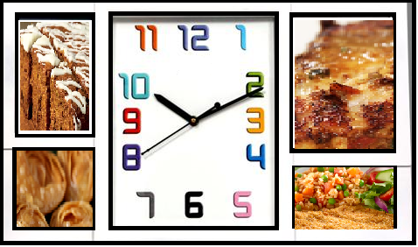 | 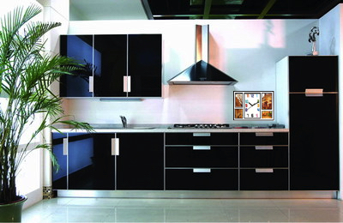
The left image is a conceptual view of the device. The center screen shall be the main screen which shall display the steps to prepare a selected recipe. The recipe shall be selected using voice command.
The right image shows how beautifully this device becomes a part of the kitchen. It has absolutely no interference with the rest of the items placed.
As “Smart Shelf” would not be feasible for prototype work, we shall use the kitchen slab (as a prototype) which shall be smart enough to scan an item and update the inventory.

Hardware Requirements

Raspberry Pi
Raspberry Pi shall be used to build the solutions proposed.

RFID Tags
Few RFID tags shall be used to identify containers.

RFID Reader
RFID Reader shall be embedded into sample slab and be used to demonstrate the scanning of items.

Breakout Board
Shall be used to build any extra electronics required during the prototype.

Jumper Wires
Shall be used to connect any extra electronics required during the prototype.

Working

Scanning
RFID reader module shall be embedded in the kitchen slab. The reason being when we put an item in the container, we generally open the container in the slab. RFID reader shall scan the items and create/update the inventory database.

Information Exchange
The format shall facilitate the recipe exchange over compatible applications.

Display
Based on the available inventory the system shall run an algorithm to see what recipes are feasible at any given point of time and accordingly stream out to the display. The main screen shall be relatively larger than the rest as it shall display the steps for preparing a recipe. The adjacent screen shall display a static image.

Recipe Selection
The display would be a touch device. When one of the recipes is selected, the main screen shall display details about the selected recipe.

References
Smart shelves - The store shelf of the future | http://www.keonn.com/news-and-success-stories/47-the-fast-growing-business-of-rfid-smart-shelves.html
The fast growing business of RFID smart shelves | http://rfidarena.com/2012/9/13/%E2%80%9Csmart-shelves%E2%80%9D-the-store-shelf-of-the-future.aspx

